The Rich Get Richer and the Poor Get Poorer:
Behavior of Investors in Biotechnology Firms Post-IPOs

Tiran Rothman
WIZO Academic College, School of Management
Haganim 21, Haifa, 31090
Israel
tiran@wizodzn.ac.il

Smadar Siev
Ono Academic College, Faculty of Business Administration, Haifa Campus
Port Gate Building, Hanamal 32, Haifa, 3303201
Israel
smadar.siev@gmail.com

Corresponding Author:
Smadar Siev
smadar.siev@gmail.com

The Rich Get Richer and the Poor Get Poorer:
Behavior of Investors in Biotechnology Firms Post-IPOs
Tiran Rothman and Smadar Siev

Abstract
This paper analyzes stocks’ price behavior after initial public offering (IPO) events in the biotechnology sector and explores the role of social media in determining this behavior. For the most part, the results indicate positive and significant cumulative average abnormal returns (CAAR) of 3.70% in the first 20 days following an IPO until the end of quiet period, and a decline of tens of percent over the three years following the IPO. However, when dividing the sample into two subsamples according to firm size, using a separation market value of $500 million, the overall picture changes dramatically. Firms with a market value lower than $500 million yielded a positive yet not significant CAAR 20 days post-IPO and a significant negative CAAR from day 50 onwards. Firms with a market value higher than $500 million experienced a significant positive CAAR from day 20 after the IPO and throughout the following year. These findings can be attributed to the limited attention of investors. Attention to the new IPOs increases until the end of quiet period and, in the case of small-sized firms, diminishes during the post-IPO years. An examination of social media and share returns demonstrates a robust correlation between the two, which may indicate that investors’ attention to these firms is also reflected in social media.

Keywords: IPO; biotechnology companies; financial markets; social media; behavioral finance

JEL Classification: D8 (Information, Knowledge, and Uncertainty); G11 (Portfolio Choice; Investment Decisions); G14 (Information and Market Efficiency; Event Studies); G17 (Financial Forecasting and Simulation).

1. Introduction
The biotechnology sector is fuelled by entrepreneurship, technology, science and finance. While technology and science are relatively accessible for entrepreneurs, funding is more challenging to find. The “new world” companies seeking to develop one or more drugs started to emerge a decade ago when technology became less expansive. Most new world companies are characterized by a lack of tangible assets and a relatively high operational risk, both of which make it difficult to find and secure funding. As a result, a growing number of biotech companies are seeking to raise public capital throughout IPOs.

1.1 Focus of the Study
This paper focuses on the “new world” of biotech firms that were traded in United States between 2013 and 2017. The first part of the paper examines how the new Jumpstart Our Business Startups Act (JOBS Act) has influenced investors’ activity during the three years post-IPO as reflected in the cumulative average abnormal return (CAAR).

The orientation of the second part of the paper is behaviouristic, identifying correlations between stock returns and social media activity. The decision-making process of participants in financial markets is not always rational and is often influenced by motives other than risk and return, such as the perceived quality of a firm. One of the channels for shaping investors’ perceptions is publishing posts about a firm through social media channels, from online message boards to Facebook and Twitter. This research focused on Twitter, as it enjoys increasing popularity and because tweets are characterized by non-scrutinized, unstructured, informal and very short texts.

In a world where there is almost an endless amount of available information, firms’ competition for investors’ attention has become fiercer than ever. We were therefore interested in exploring how the discourse level of Twitter comments, without any potentially controversial evaluation of their content, influence main capital market variables after the IPO.

  - Regulatory Periods of an IPO
The public offering process is characterized by four regulatory periods. The first is the pre-filing period, which begins when the company chooses an underwriter and ends when a company files a registration statement with the U.S. Security and Exchange Commission (SEC). During this period, offers cannot be made, prospective purchasers cannot be contacted and the identity of underwriters cannot be publicly disclosed. The second regulatory period, “the waiting period,” known also as the pre-effective period, begins when the company files a registration statement with the SEC and ends when the registration statement is declared effective. During this waiting period, the federal securities laws limit the information a company and related parties can release to the public. Offers are permitted only if made orally or by using a preliminary prospectus. Indications of investment interest are permitted, but sales of the securities are prohibited. In 2005, the SEC changed a number of provisions regarding this period and permitted companies to continue publishing information about the company electronically and to continue publishing and reporting company activities through normal company networks. The third period, the Post-Effective Period, begins when the registration statement is declared effective by the SEC. During this period, sales and certain communications are permitted if they are accompanied or preceded by a final prospectus. This period ends after 25 days and underwriters or broker-dealers are then no longer required to deliver a prospectus and they may launch coverage. At this point, underwriters initiate coverage of the company, most often with buy recommendations, and the company starts issuing press releases. The federal securities laws do not define the term “quiet period.” Some refer to the waiting period as the quiet period, which begins when the company files a registration statement with the SEC and ends when the registration statement is declared effective. Others refer to the 25th day after the IPO as the end of the quiet period, as do we in this paper. In the fourth, or lock-up period, major shareholders are prohibited from selling their shares. Lock-up periods usually last between 90 to 180 days after the IPO. Once the lock-up period ends, most trading restrictions are removed.
Another relevant legislation to our study is the JOBS Act that was enacted in the United States in April 2012. This act has altered the new world environment, establishing, inter alia, a new process of disclosures for public offerings by a new class of companies referred to as emerging growth companies (EGCs). According to SEC regulations, an EGC is defined as a company which first sold its equity in a registered offering after December 8, 2011, and which has total gross annual revenues of less than $1 billion during its most recently completed fiscal year. The JOBS Act was designed to boost job creation by giving smaller companies access to the capital needed to expand their businesses. Companies that qualify can file draft IPO registration statements confidentially with the SEC. They are also able to file two years of audited financial statements instead of three, to delay compliance with the Sarbanes-Oxley Act requirement for auditor opinions on internal controls, and to delay implementation of new or revised accounting standards. Even more significant is the newly permissible use of “test-the-waters” communications with qualified institutional buyers and institutional accredited investors. Thus, EGCs are allowed to reach qualified institutional buyers before the lock-up period ends.
Below is a general description of IPO regulation periods:
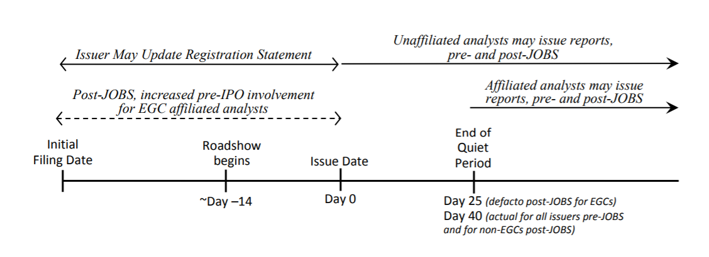

1.3 IPO and Stock Performance
While numerous issues involving IPOs have been widely studied, those most relevant to this study address share performance up to three years following the IPOs. Jain and Kini (1994) showed low performance of IPOs for up to three years after the offering, and Loughran and Ritter (1995) reported that IPO stocks yielded an average of 5% over a one-year post-IPO period, compared to 12% for a comparably-sized non-IPO benchmark. In a seminal paper, Ritter and Welch (2002) investigated the long-term performance of IPOs and found that the three-year average market-adjusted return on IPOs was a negative 23.4%. In contrast, a study conducted by Goergen et al. (2009) on IPOs in France and Germany issued during the period 1996–2000 found no significant abnormal returns. Chang et al. (2017) found that applying a simple buy-and-hold strategy for three years after the purchase of one share of every company issuing an IPO between 1980 and 2015 would yield an 18.7% decline in value, with shares of technological firms exhibiting even greater declines. Researchers have also been puzzled about declines in returns close to the expiration of IPO lock-up periods, and some studies have concluded that the market reacts negatively to lock-up periods expirations. The research of Ofek (2000), conducted in the United States from 1996 through 1998, found an abnormal negative return during this period as well as a 1% to 3% drop in the stock price, and a 40% increase in volume 180 days after the IPO. Examining IPOs in the United States from 1988 through 1997, Bradley et al. (2001) (See also, Brav and Gompers [2003], and Field and Hanka [2001]) all observed negative abnormal returns of approximately 2% near the time of the lock-up period’s expiration.

1.4 Media and Stock Performance
According to Merton (1987), the most common way to boost investors’ awareness is to promote the visibility of the firm through the media. Shiller (2000) wrote:
The role of the news media in the stock market is not, as commonly believed, simply as a convenient tool for investors who are reacting directly to the economically significant news itself. The media actively shape public attention and categories of thought, and they create the environment within which the stock market events we see are played out.

Shiller (2000) found that extra media coverage draws investors’ attention to these stocks. This leads to a positive feedback effect, in which big returns are followed by more big returns because of increased media coverage. In contrast, Fang and Peress (2009), who analyzed the effect of the media coverage magnitude on stock returns in the U.S stock market, found that a portfolio of stocks not covered by the media outperformed a portfolio of stocks with high media coverage by 3% per year following portfolio formation. In their view, the “no media premium” may stem from limitations on trading or to compensation for little or lack of information.

Bhattacharya at, et al. (2009) explored the role of the media in the internet IPO bubble between 1996 and 2000. They found that media coverage was much more intense for internet IPOs. There were more total new items, more good news and more bad news for internet IPOs than for a matching sample of non-internet IPOs. They found that the media intensified their coverage of good news for internet IPOs in the bubble period and intensified their coverage of bad news for internet IPOs in the post-bubble period. The effect on daily abnormal returns, which was lower for internet IPOs, especially during the bubble period, indicates that the market largely discounted the media hype.

Siev (2014) also documented a gap in stock returns between firms publishing a low number of press releases (PRs) and those publishing a high number of press releases, with the former enjoying higher returns. This gap (PR Premium) was found for both the year in which the PR was published and the year following, with a magnitude of 7–8% and 5–6%, respectively. The analysis also indicated that the average daily trading volume of firms with a high PR volume was three times higher than that of firms with a low PR volume. The difference in trading volume supports the hypothesis that perceived company image can influence financial trading activity. Applying the same logic, firms that enjoy a high level of public attention due to a much higher volume of annual PRs get noticed more, which leads to overpricing, which can ultimately yield lower returns.

In addition to the information generated by the firms and the press, discussed in the previous section, firm-related information is also disseminated by the investment community using online social media.
One of the earliest studies conducted about internet stock messages boards was that of Wysocki (1998), which examined what characterizes firms whose stocks receive the highest volume of posted messages. He found that the most attention-grabbing firms were characterized by: extreme returns, either high or low; high market value; high price/earnings (P/E) ratio; high book-to-market ratio; high volatility; high trading volume; and high analyst coverage. Wysocki (1998) also found that an increase in overnight message postings led to a positive abnormal return and an increase in trading volume on the next day. Studies on the online social networks effect, such as that of Antweiler and Frank (2004), found a direct correlation between internet message board activity on one hand, and stock volatility and trading volume on the other. The authors determined that when many messages were posted on a given day, there was a negative return on the next day. Das and Chen (2007) found a negative correlation between changes in the number of messages and changes in the contemporaneous stock prices. According to Chen et al. (2014), the views expressed in both articles and commentaries posted on a popular social media outlet predicted future stock returns for a period of three months after their publication.

Other studies examined blog posts to predict stock market behavior. Gilbert and Karahalios (2010) used over 20 million posts from the LiveJournal website to create an index of the national mood in the United States, which they call the Anxiety Index. They found that when this index rose sharply, the S&P 500 Index ended the same day marginally lower than was expected.

In their initial work, Zhang et al. (2011) analyzed a sample of Twitter posts for six months on a daily basis to measure collective fear and hope. Examining whether these collective emotions correlated with major stock indices in the U.S. market, the authors found that “emotional tweet percentage significantly negatively correlated with Dow Jones, NASDAQ and S&P 500, but displayed significant positive correlation to VIX.” Forbergskog and Blom (2014) demonstrate that the positive and negative sentiment extracted from tweets could predict both positive and negative S&P 500 returns the following day. Furthermore, Sul, et. al. (2014) showed that sentiment polarities extracted from tweets positively correlated with intraday returns of the S&P 500, and Twitter users with more followers had greater influence on the returns. Liew and Wang (2016) documented a contemporaneous relationship between IPOs’ tweet sentiment and returns in the first trading day. In addition, they found that tweet sentiment in the days preceding the IPO could predict the IPO’s first-day returns from opening price to closing price.

2. Stock Behavior Post-IPO
2.1. Research Goals and Hypotheses
As described above, in the first 25 days after an IPO is priced and opens for trading, underwriters and their affiliated analysts are not allowed to publish any research about the company. Consequently, the stock trades as an “uncovered” stock. The ending of the quiet period is important, because the simultaneous launching of coverage by several underwriters on that day can have a significant impact on the stock price. The end of the quiet period has changed over the years, and the SEC recently shortened it to 10 days after the IPO. However, the vast majority of investment banks still observe the 25-day rule, so that outside coverage commences 25 days after first day of the IPO pricing. Our goal was to investigate CAAR behavior from the IPO date to the end of the quiet period and thereafter.

Thus, it can be expected to see an upward trend in CAAR during the quiet period and a downward trend after the quiet period ends. An increase in CAAR is expected due to the natural hype immediately following the IPO. The later downward trend can be explained, in part, to the publishing of numerous reports about the company or its sector and future forecasts by affiliated analysts. Dividing the sample into two subsamples according to firm size, we expect to observe better performance among large-sized firms because large-sized firms are likely to have more experience, more available resources and a bigger product portfolio. The presence of these factors is likely to enhance a large firm’s potential for future success as well as to attract greater attention from investors. We formulated the following hypotheses to reflect these expectations:

H1: Quiet Period: Stock’s return until the end of the quiet period:
The natural hype from the new IPO will yield positive CAAR from the IPO date until the end of the quiet period.

H2: Quiet Period: Stocks return post-quiet period:
As coverage initiates by underwriters and their affiliated analysts at the end of the quiet period, and as the initial hype diminishes, the stock will experience a negative CAAR.

H3: Sock returns and market capitalization:
Large-sized firms are likely to perform better than small-sized firms, due to their higher potential for future success and their greater share of investor attention.

2.2 Data and Method
Our initial database consisted of all biotech companies that issued IPOs in the period from January 2013 to November 2017. Data was extracted from the EvaluatePharma database and consisted of 283 companies. We focused on companies traded in the United States, thus excluding firms traded on non-U.S. stock exchanges. We also excluded firms that became private or were merged into or acquired by others from the time of the IPO until three years following the IPO. Our final database consisted of 182 firms. Table 1 displays the number of IPOs per year in our final database.

Table 1: IPOs per year
Year | No. of IPOs
2013 | 30
2014 | 70
2015 | 49
2016 | 29
2017 | 4
Total | 182

Note: This table presents the number of IPOs per year in the final database.

A prominent feature of the firms in our sample is their relatively low market capitalization, as can be seen in Table 2. The average market value is $454.2 million and the median market value is $287.1 million.

Table 2: Market Value as of December of the IPO Year ($million)
Average | 454.2
Median | 287.1
Min. | 1.3
Max. | 2,346.70
Std. Dev. | 494.4

Note: This table presents descriptive statistics of the market capitalizations of the 182 firms studied.

The event study approach was employed to examine market reaction to IPO events. The actual date of the IPO was marked as t=0 and the daily stock prices extracted from the NASDAQ website and Yahoo Finance were applied for the period t=0,..,755 (three years post-IPO), to calculate daily logarithmic returns. Two return benchmarks were utilized: the IXJ Healthcare Index, and the S&P 500 Market Index. The Cumulated Abnormal Return (CAR) was calculated by subtracting the benchmark returns from the stock return. As no stock prices exist prior to the IPO, conditional return using the market model was not calculated. Due to the low average market value of $454.2 million (Table 2), we sought to explore the difference in CAARs in relation to firm size. Consequently, we divided our database into two subsamples of small and large firms and calculated the CAAR for each of them. The average rounded market value of $500 million was chosen as a threshold to differentiate between small-sized and large-sized firms.

In addition, normalized trading volumes were computed as a proxy for market attention. For each firm in the sample, the natural logarithm of the daily trading volume throughout the period t=0,.., 755 was recorded, and each observation was normalized by subtracting the mean and dividing by the standard deviation calculated over the period. Then, the average across all firms for each day relative to the IPO date was calculated.
2.3 Results
The CAAR results for selected time periods during the three years post-IPO are presented in Table 3. Panel A presents the results for the entire sample. Panel B presents the results for firms with a market capitalization ≤ $500 million (70% of the sample), or small-sized firms. Panel C presents the results for the firms with a market capitalization higher than $500 million (30% of the sample), or large-sized firms. Results are shown for the two benchmarks of market and sector indices. As the CAAR results relative to the two benchmarks are similar, reference will be made only to the sector index benchmark. Figure 1, Panels A–C describes the daily CAAR and normalized trading volumes for the entire sample, of small-sized firms and large-sized firms respectively.

As shown in Panel A of Table 3, the CAAR that was calculated for the first 20 trading days post-IPO is positive, significant, and equals 3.7% (t = 2.18). These results support our H1 hypothesis. After 20 trading days, performance began to decrease, diminishing significantly until the 50th trading day, with CAAR = 0.26% (t = 0.09). One hundred trading days post-IPO, CAAR = - 7.11% (t = -1.68); 200 trading days post-IPO, CAAR = -20.57% (t= -3.42); 250 trading days post-IPO CAAR = -21% (t = -3.18); two years (550 trading days) post-IPO, CAAR = -50.33% (t = -4.92); and three years (755 trading days) post-IPO, CAAR = -70.66% (t = -5.54). Panel A in Figure 1 shows that the CAAR decline was consistent from day 20 onward. These results are consistent with previous literature and support hypothesis H2.
With respect to small companies (Table 3, Panel B), CAAR for the first 20 trading days post-IPO was positive yet not significant, with CAAR = 1.44% (t = 0.92). Fifty trading days post-IPO, CAAR was negative and significant, at -5.12%, (t = -1.64); 100 trading days post- IPO, CAAR was
-15.63%, (t = -3.35); one-year post-IPO, CAAR was negative, at -33.72% (t = -4.45). Panel B in Figure 1 shows that the decline started on day 25 and continued consistently from that point onward. The results for large firms (Table 3, Panel C) reveal a completely different picture. After 20 trading days, CAAR was positive and significant, with CAAR = 9.06%, (t = 2.19); after 50 trading days, CAAR = 13.01%, (t = 2.26); after 100 trading days CAAR = 13.08% (t = 1.73). One year after the IPO, CAAR = 9.14% (t = 0.83). The refined picture of daily CAAR is presented in Panel C of Figure 1. CAAR reaches its peak of 15.76% on day 165 post-IPO and begins to decline from that point until it disappears completely 596 days post-IPO. Another prominent finding is that large firms’ CAAR was much more volatile than small firms’ CAAR.

Specifically, investors’ activity post-IPO differs according to the firm’s size. Small-sized firms exhibited negative CAAR in the first year post-IPO and large firms exhibited positive CAAR in the first year post-IPO. These findings support hypothesis H3.

Table3: Post-IPO CAARs, +1 to +755 days
Panel A: The Entire Sample
Days Relative to Event | Deviation from Market Index |  | Deviation from Sector Index
Days Relative to Event | CAAR, % | t-stat. | CAAR, % | t-stat.
1 to 10 | 0.58% | 0.47 | 0.50% | 0.38
1 to 20 | 3.88% | 2.35 | 3.70% | 2.18
1 to 50 | 0.60% | 0.19 | 0.26% | 0.09
1 to 100 | -6.83% | -1.54 | -7.11% | -1.68
1 to 150 | -12.17% | -1.96 | -12.84% | -2.42
1 to 200 | -19.75% | -2.76 | -20.57% | -3.42
1 to 250 | -19.80% | -2.58 | -21.00% | -3.18
1 to 550 | -54.05% | -4.92 | -50.33% | -4.92
1 to 755 | -77.45% | -5.77 | -70.66% | -5.54
Observations | 182 |  | 182

Panel B: Small-Sized Firms (market cap < $500 million)
Days Relative to Event | Deviation from Market Index |  | Deviation from Sector Index
Days Relative to Event | CAAR | t-stat. | CAAR | t-stat.
1 to 10 | 0.12% | 0.10 | 0.09% | 0.07
1 to 20 | 1.57% | 1.04 | 1.44% | 0.92
1 to 50 | -4.89% | -1.22 | -5.12% | -1.64
1 to 100 | -15.61% | -2.93 | -15.63% | -3.35
1 to 150 | -23.41% | -2.93 | -23.79% | -2.99
1 to 200 | -33.56% | -3.67 | -34.12% | -3.74
1 to 250 | -32.60% | -3.35 | -33.72% | -4.45
1 to 550 | -77.32% | -5.56 | -73.48% | -5.30
1 to 755 | -101.50% | -5.97 | -92.61% | -5.47
Observations | 128 |  | 128

Panel C: Large-Sized firms (market cap > $500 million)
Days Relative to Event | Deviation from Market Index |  | Deviation from Sector Index
Days Relative to Event | CAAR | t-stat. | CAAR | t-stat.
1 to 10 | 1.69% | 0.52 | 1.45% | 0.44
1 to 20 | 9.35% | 2.30 | 9.06% | 2.19
1 to 50 | 13.63% | 2.38 | 13.01% | 2.26
1 to 100 | 13.97% | 1.85 | 13.08% | 1.73
1 to 150 | 14.48% | 1.60 | 13.12% | 1.44
1 to 200 | 13.00% | 1.27 | 11.55% | 1.14
1 to 250 | 10.51% | 0.95 | 9.14% | 0.83
1 to 550 | 1.51% | 0.10 | 4.92% | 0.31
1 to 755 | -19.54% | -1.03 | -12.10% | -0.64
No. of firms | 54 |  | 54

Note: This table displays Cumulative Average Abnormal Return for the entire sample and the two subsamples of firms with market valuations below $500 million (Panel B) and above $500 million (Panel C) as of December of the IPO year.

Figure 1: Post-IPO CAARs, +1 to +755 days
Panel A: The Entire Sample
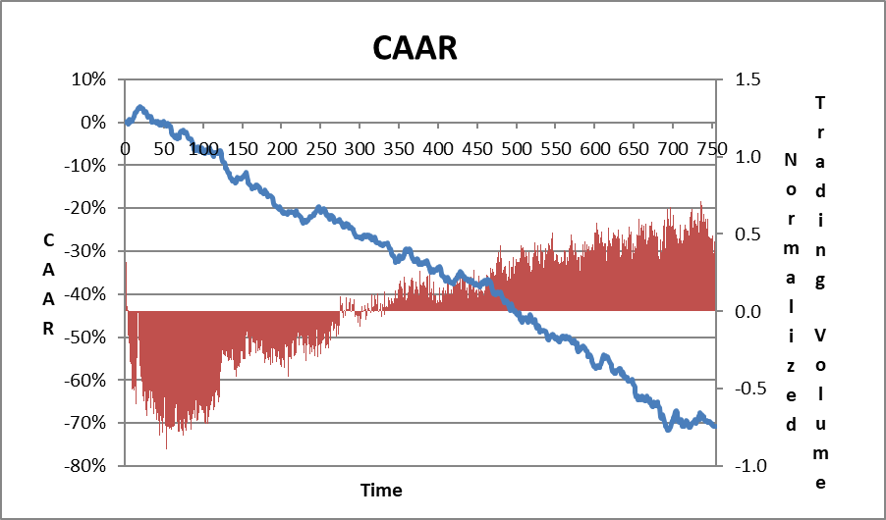
Panel B: Small Firms (market value < $500 million)

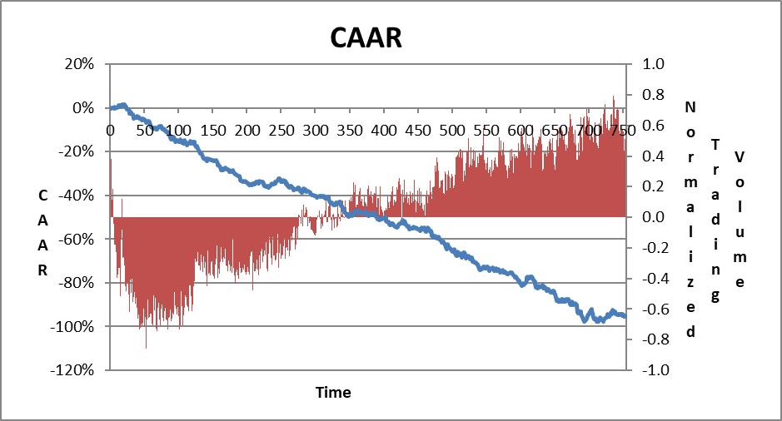

Panel C: Large Firms (market value > $500 million)

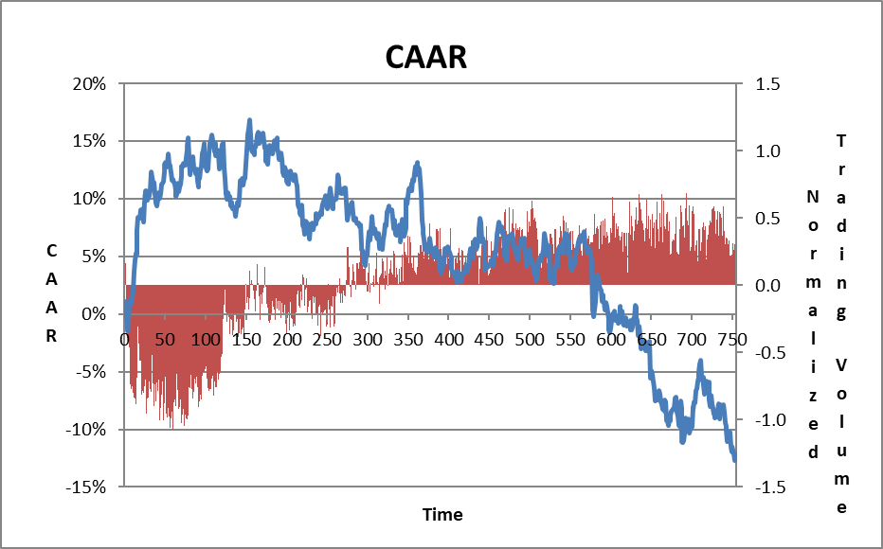

Note: These figures present daily CAAR after the IPO from day 0 to day 755. Panel A presents CAAR for the entire sample. Panel B presents CAAR for small firms and Panel C presents CAAR for large firms. CAAR was calculated relative to the sector index.

In terms of trading volumes, the IPO day was characterized by the highest trading volume during the entire three-year post-IPO period. On the second trading day, trading volumes decreased substantially and from that point on, trading volumes showed an increasing growth trend over time for both small and large firms (see Figure 1, Panels A–C). A comparison of trading volumes between small-sized and large-sized firms reveal that in the first 20 trading days post-IPO, the trading volume of small-sized firms was twice that of large-sized firms. During the three years following the IPO, there was no advantage for small or large firms with respect to trading volume Half the time, the trading volume of small firms exceeded that of large firms and vice versa.

Investors’ activity on the Twitter social media platform before and after the IPO will now be examined. The relation between Twitter volume and stock returns will be explored. In addition, based on the results above, we look at the relation between the firm size and the Tweet volume, analyzing, inter alia, whether firms use social media as a tool to promote a successful IPO.

3. Social Media and IPOs
When considering the volume of tweets as a reflection of the level of attention a firm has attracted, it should be noted that the volume of tweets has been weighted relative to the tweet volume of other firms. As a result, even a low tweet volume can stand out in an environment where comparable firms have a lower volume or no tweets at all, thereby creating an impact, perhaps even similar to that of a firm with very high tweet volume in an environment of high tweet volumes. Therefore, the mere number of tweets itself is often meaningless; the number becomes more meaningful only when compared with others in the comparable sector. For that reason, the number of tweets above and below the median for each year relative to the IPO have been characterized as High Twitter Volume (HTV) and Low Twitter Volume (LTV) respectively.
3.1 Research Goals and Hypotheses
Our goal was to analyze the correlation and possible causality between the annual volume of tweets about a firm and that firm’s main capital market variables. The expectation was that a positive relationship would be found, so that large-sized firms, high trading volumes and high returns would increase investor interest, which would be reflected in a higher volume of tweets, and, conversely, that higher volumes of tweets would draw investors’ attention, which would be reflected in higher market activity. In addition, it was expected to find causality between the annual volume of tweets about a firm and that firm’s returns, so that a high volume of tweets in a given period would have positive impact on returns in the ensuing period.

We formulated the following hypotheses to reflect these expectations:

H4: Correlation: There will be a positive correlation between Twitter volume and capital market variables: risk, returns, trading volume and market capitalization.

H5: Causality: a: There will be a positive causality between the annual volume of tweets
about a firm and its annual returns.
b: There will be positive causality between the volume of tweets a firm
receives in periods of less than one year, one week, two weeks and
one month prior to the IPO, and returns in parallel periods post-
IPO.

3.2 Data and Method
For each firm in our sample, we downloaded its related tweets using Python programing, starting from the calendar year preceding the IPO day and up to three calendar years post-IPO. We extracted all tweets containing: full company name, $ + firms’ ticker and also the company’s twitter user name if there was one, such as @chimerix for Chimerix. Next, we excluded all unrelated tweets in which the company name appeared in a non-company context, such as “Adam Kadmon” for Kadmon. Our Twitter database consisted of daily tweets for each company and contained over 1.5 million tweets. Table 4 displays descriptive statistics regarding the annual volume of tweets. The actual date of the IPO was marked as t=0, we name the pre IPO days -250 – 0 as IPO year-1, post-IPO days 0–250 as IPO year, post-IPO days 251–501 as IPO year+1 and post-IPO days 502–755 as IPO year+2.
Table 4: Volume of Tweets: Descriptive Statistics
 | IPO Year-1 | IPO Year | IPO Year+1 | IPO Year+2
Average | 359 | 2,237 | 3,083 | 3,558
Median | 246 | 1,524 | 2,377 | 2,326
Std. Dev. | 377 | 2,690 | 2,978 | 3,976
Min. | 0 | 0 | 197 | 15
Max. | 2,035 | 26,126 | 20,022 | 27,579
No. of Tweets | 65,349 | 407,067 | 548,815 | 542,232
No. of firms | 182 | 182 | 178 | 147
Note: This table presents Twitter volume descriptive statistics for one year before the IPO up to three years post-IPO.

Two main findings emerged, as presented in Table 4. First, the average annual number of tweets increased over the years, from 359 during the year preceding the IPO, through 2,237 tweets during the IPO year and up to 3,558 tweets two years after the IPO. The second notable observation is the huge variance in the annual volume of tweets among the firms. For example, in Adverum Biotechnologies’ IPO year, it had zero tweets, while Juno Therapeutics had over 26,000 related tweets in its IPO year. The growing number of annual tweets reflects both the growth in Twitter’s popularity and the increased interest in firms over time.

To explore the relations between the volume of tweets and capital market variables, both univariate and multivariate analyses were employed. In the univariate analysis, several capital market variables were calculated for each firm in our database and compared the average of these variables between the LTV and HTV groups. The compared variables were: Return (t), the rate of return on a firm’s stock at period t; Trading volume (t), a firm's daily average trading volume at period t; and Std. Dev. (t), the standard deviation of daily returns calculated over the period and used as a proxy for total risk. Beta is a proxy for systematic risk coefficients. Estimations, were made from the market model regression on the S&P 500 Index returns using the first 50 trading days after the IPO and therefore is displayed for the year of the IPO only. Market value (t) was calculated as the number of shares for December of that year multiplied by the stock price of that day.

The multivariate analysis employs two sets of ordinary least squares (OLS) linear regressions to analyze the contemporaneous relation between annual volume of tweets and the annual returns and abnormal returns. The regression equations were:

(2)

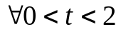

Explained variables were returns and abnormal returns. The abnormal return was calculated relative to two benchmarks: The S&P 500 Index and the IXJ index. Explanatory variables were: Beta; HTV as a dummy variable that receives 1 for companies with a high volume of tweets and 0 otherwise. The dummy variables for the IPO years 2013–2017 are Y2013 to Y2016, which are aimed at capturing potential influence during a given year. Normalized Market Value (NMV) was calculated for each firm for each year relative to the IPO date by subtracting the firms’ average market value from a firm’s value and dividing by standard deviations of the firms’ market value.

Additional multivariate analyses employing causality tests will be detailed later.

3.3 Results

3.3.1 Univariate Analysis
Table 5 presents descriptive statistics for some capital market variables for the years following the IPO. Panel A presents the IPO year, panel B presents IPO year+1, panel C presents IPO year+2 and Panel D presents absolute tweet volume for small-sized and large-sized firms. Results suggest that firms that were characterized by higher tweet volume (HTV) were also characterized by higher risk (total and systematic), higher returns, higher trading volumes and higher market values compared to LTV firms. For example, differences in returns reached: 7% (p-value = 0.08) in the IPO year, 51% (p-value = 0.001) in the following year and 29% (p-value = 0.04) in the IPO year+2. Trading volumes for the HTV firms were 2.7–2.8 times higher than for the LTV firms and market value was 1.7–2 times higher for the HTV firms. As presented in Panel D, large-sized firms were also characterized by a higher tweet volume in the year before the IPO and in the IPO year. These results support our H4 hypothesis.

Table 5: Capital Market Variables: Descriptive Statistics for HTV and LTV Firms
Panel A: IPO Year
 | LTV | HTV | Diff | P-Value of Diff.
Beta (50 Days) | 0.68 | 1.00 | 0.31 | 0.03
Return’s Volatility | 0.05 | 0.12 | 0.07 | 0.14
Return | 0.05 | 0.12 | 0.07 | 0.08
Trading Volume | 94,321 | 267,332 | 173,011 | 0.00
Market Value ($M) | 322.74 | 585.66 | 262.91 | 0.00
Observations | 91 | 91

Panel B: IPO Year+1
 | LTV | HTV | Diff. | P-Value of Diff.
Return’s Volatility | 0.044 | 0.057 | 0.013 | 0.001
Return | -0.15 | 0.36 | 0.51 | 0.001
Trading Volume | 162,046 | 441,602 | 279,556 | 0.000
Market Value ($M) | 418.17 | 844.56 | 426.38 | 0.001
Observations | 89 | 89

Panel C: IPO Year+2
 | LTV | HTV | Diff. | P-Value of Diff.
Return’s Volatility | 0.04 | 0.06 | 0.01 | 0.000
Return | 0.00 | 0.29 | 0.29 | 0.043
Trading Volume | 244,890 | 660,862 | 415,973 | 0.000
Market Value ($M) | 493.44 | 841.79 | 348.35 | 0.017
Observations. | 75 | 72

Panel D: Absolute Tweet Volume per Firm Size
Absolute Tweet Volume | Small | Large | P-value of Diff.
IPO Year -1 | 310 | 474 | 0.01
IPO Year | 2,068 | 2,636 | 0.07
IPO Year+1 | 3,063 | 3,135 | 0.43
IPO Year+2 | 3,404 | 4,001 | 0.20

Note: Panels A to C present descriptive statistics of market variables for the sample firms divided into LTV and HTV firms. Panel D presents absolute annual tweet volume from one year before the IPO through three years after the IPO.

3.3.2 Multivariate Analysis
In light of the positive contemporaneous correlation found between annual tweet volume and company returns, we conducted the regression analysis as set forth in equations 1 and 2. The regression results are displayed in Table 6. Panels A, B and C display the results for the IPO year,
IPO year +1 and IPO year+2 years respectively.

The extended and the limited models are presented for each year. In cases that the tweet annual volume was not part of the limited model, we analyzed its contribution as an addition to the limited model and as a stand-alone variable. We presented only the Abnormal Return (AR) regression results relative to the sector index due to similarities between the two selected benchmarks.
Table 6: The Effects of Tweet Volume on Returns and Abnormal Returns (AR): Regression
Results
Panel A: IPO Year
 | Return |  |  |  | AR to Sector
 | Model 1 | Model 2 | Model 3 | Model 4 | Model 5 | Model 6 | Model 7 | Model 8
Intercept | 1.63 (0.00) | 1.71 (0.00) | 1.76 (0.00) | 0.07 (0.48) | 1.38 (0.01) | 1.48 (0.00) | 1.51 (0.00) | -0.05 (0.59)
Year 2013 | -1.12 (0.04) | -1.13 (0.04) | -1.29 (0.02) |  | -1.12 (0.04) | -1.13 (0.03) | -1.29 (0.02)
Year 2014 | -1.20 (0.02) | -1.21 (0.02) | -1.4 (0.01) |  | -1.11 (0.03) | -1.13 (0.03) | -1.31 (0.01)
Year 2015 | -1.94 (0.00) | -1.94 (0.00) | -2.12 (0.00) |  | -1.66 (0.00) | -1.66 (0.00) | -1.83 (0.00)
Year 2016 | -1.59 (0.00) | -1.56 (0.00) | -1.8 (0.00) |  | -1.46 (0.01) | -1.43 (0.01) | -1.67 (0.00)
Beta | -0.13 (0.03) | -0.12 (0.05) | -0.14 (0.03) |  | -0.14 (0.02) | -0.13 (0.04) | -0.15 (0.02)
NMV | 0.22 (0.00) | 0.24 (0.00) |  |  | 0.22 (0.00) | 0.24 (0.00)
HTV | 0.18 (0.20) |  | 0.30 (0.03) | 0.21 (0.15) | 0.21 (0.12) |  | 0.33 (0.02) | 0.25 (0.07)
Adjusted R- Squared | 0.20 | 0.20 | 0.16 | 0.01 | 0.16 | 0.15 | 0.11 | 0.01
Observations | 182 | 182 | 182 | 182 | 182 | 182 | 182 | 182

Panel B: IPO Year+1

 | Return |  |  | AR to Sector
 | Model 1 | Model 2 | Model 3 | Model 4 | Model 5 | Model 6
Intercept | 0.06 (0.69) | -0.08 (0.34) | -0.15 (0.10) | -0.04 (0.80) | -0.13 (0.13) | -0.19 (0.03)
Year 2013 | 0.08 (0.69) |  |  | 0.05 (0.83)
Year 2014 | -0.44 (0.02) |  |  | -0.30 (0.10)
Year 2015 | 0.02 (0.92) |  |  | 0.02 (0.91)
Beta | 0.00 (0.94) |  |  | 0.01 (0.82)
NMV | 0.27 (0.00) | 0.27 (0.00) |  | 0.26 (0.00) | 0.26 (0.00)
HTV | 0.39 (0.00) | 0.38 (0.00) | 0.51 (0.00) | 0.38 (0.00) | 0.37 (0.00) | 0.50 (0.00)
Adjusted R- Squared | 0.18 | 0.17 | 0.08 | 0.18 | 0.16 | 0.08
Observations | 178 | 178 | 178 | 178 | 178 | 178

Panel C: IPO Year+2
 | Return |  | AR to Sector
 | Model 1 | Model 2 | Model 3 | Model 4
Intercept | 0.08 (0.62) | 0.00 (0.98) | -0.02 (0.89) | -0.09 (0.44)  09 (0.44)
Year 2013 | -0.74 (0.00) |  | -0.6 (0.02)
Year 2014 | -0.05 (0.8) |  | -0.05 (0.79)
Beta | 0.00 (0.97) |  | 0.00 (0.98)
NMV | 0.02 (0.77) |  | 0.02 (0.79)
HTV | 0.49 (0.01) | 0.29 (0.08) | 0.48 (0.01) | 0.32 (0.05)
Adj. R-Squared | 9.4% | 2.08% | 4.3% | 2.04%
Observations | 147 | 147 | 147 | 147

Note: This table displays the results of OLS regressions in which the dependent variables were Return and Abnormal Return. P-values are in parentheses. Because our data ends in 12/1/18, firms for which the IPO took place after Dec. 1, 2017 were excluded from the IPO year +1 analysis. For the IPO year +2, firms for which the IPO took place after Dec.1, 2016 were excluded.

For the IPO year (Table 6, Panel A), tweet volume was not part of the limited models (Models 2 and 6). The tweet volume receives explanatory power in the absence of the normalized market value (NMV) variable: 0.3 in Model 3 (p-value = 0.03) and in 0.33 in Model 7 (p-value = 0.02). As a stand-alone variable (Model 8), the tweet volume coefficient was 0.25 (p-value = 0.07) and explains 1% of the AR variance. The significant coefficients of the years and the intercept capture the change in a firm’s return and abnormal return during the first year after the IPO for each year of issue. The Beta coefficient was negative. The NMV coefficient was found to be significant and ranged between 22% and 24%.

Regressions conducted for the IPO year+1 )Table 6, Panel B(, showed that HTV firms yielded higher returns and abnormal returns of 37–39% than did LTV firms (Models 1,2, 4 and 5). Another interesting result was that the volume of tweets as a stand-alone variable explained 8% of the variance of the returns and abnormal returns (Models 3 and 6). The NMV coefficient was positive and significant across all the models, indicating that returns and abnormal returns grew along with firms’ values.

Regarding the IPO year+2, (Table 6, Panel C), the volume of tweets was the only significant coefficient. As a stand-alone variable it explained 2% of the variance of returns and abnormal returns (Models 2 and 4). Companies characterized by a high volume of tweets demonstrate 29–32% higher returns and abnormal returns relative to firms with a low volume of tweets.
We turn now to examine the causality between tweet volume and returns. We conducted three sets of regressions. First, we examined whether tweet volume in a certain year affected stock returns in the following year. Specifically, we conducted the following regressions:

(3)

(4)

No causality was found.

In light of these results, we analyzed smaller time periods and were interested mainly in the time period around the time of the IPO. Therefore, we explored the combinations of the periods of: one week, two weeks, and one month before and after the IPO. Thus, we analyzed whether high or low tweet volume one week, two weeks or one month before the IPO affected the post-IPO returns one week, two weeks or one month after the IPO. Here, too, no causality was found.

Third, we employed Granger's (1969) causality approach. We analyzed whether returns could be explained by lagged values of returns and whether adding lagged value of HTV improves this explanation. We also examined the reverse direction, asking whether tweet volume can be explained by its lagged values and whether a lagged value of returns adds explanatory power.
The regression equations were:

(5)

(6)

Regression results are displayed in Table 7.

Though very small, IPO year+1 return has some explanatory power for the next year’s return (Adjusted R² = 2%). However, high tweet volume at the IPO year+1 did not explain the next period’s return (Panel A). Regarding the reverse direction (Panel B), high tweet volume during IPO year +1 was a good predictor for high tweet volume during IPO year +2 (R²=17%). The return at IPO year +1 did not explain the realization of high or low tweet volume in the consecutive year. Both regressions present a contemporaneous relationship between tweet volume and returns during the IPO year +2.
Table 7: Granger’s Causality tests

Panel A: Dependent Variable Return (IPO Year +2)

 | Model 1 | Model 2 | Model 3 | Model 4
Intercept | 0.16 (0.05) | 0.167 (0.05) | 0.14 (0.25) | 0.15 (0.23)
Return IPO Year+1 | -0.17 (0.05) | -0.18 (0.04) | -0.18 (0.05) | -0.24 (0.02)
Return IPO Year |  | -0.05 (0.6) | -0.05 (0.58) | -0.09 (0.33)
HTV IPO Year+1 |  |  | 0.05 (0.79) | 0.06 (0.73)
NMV Dec. IPO Year+2 |  |  |  | 0.13 (0.15)
Adjusted R- Squared | 2.00% | 1.51% | 0.87% | 1.61%
Observations | 147 | 147 | 147 | 147

Panel B: Dependent Variable HTV(IPO Year +2)
 | Model 1 | Model 2 | Model 3
Intercept | 0.26 (0.00) | 0.25 (0.00) | 0.25 (0.00)
HTV IPO Year +1 | 0.42 (0.00) | 0.41 (0.00) | 0.4 (0.00)
HTV IPO Year |  | 0.04 (0.66) | 0.04 (0.64)
Return IPO Year+1 |  |  | 0.02 (0.68)
Adjusted R- Squared | 17.0% | 16.6% | 16.1%
Observations | 147 | 147 | 147

Note: This table displays Granger’s causality tests. P-values are in parentheses.
To conclude, we did not find any causality between tweet volume, high or low, and returns in either direction.

4. Discussion and Conclusions
During the last few decades, psychological aspects of decision-making have been successfully integrated into economic modeling, adding to the descriptive power of the traditional normative approach based on rational expectations. Numerous study results indicating individuals’ cognitive limitations have been documented as part of this trend.
Contributing to this line of work, we have focused on the post-IPO period of biotechnology firms representing the “new world” of firms. Most of these are small-sized firms developing one or only a few drugs. Therefore, investors’ attention has enormous influence on companies’ share prices. The phenomenon of a collapse in shares’ CAAR after IPO has been well known for years (see Loughran and Ritter, 1995 and Ritter and Welch, 2002). However, only a small portion of the studies have focused on the biotechnology sector, despite this sector being ranked as a leading one based on its revenues. Furthermore, the change in regulations signified by the passage of the JOBS Act in 2012 has dramatically altered investors’ approach to these kinds of small-sized firms, resulting in these firms receiving more attention from capital markets.

This study documents CAAR's behavior following IPO_{S} of innovative biotechnology firms. The overall picture of stock performance after IPOs indicates that firms receive short-term hype immediately after the IPO with positive and significant CAARs that peak close to the end of the quiet period 20 days after the IPO. This increase in CAAR is followed by a consistent and long decline in the subsequent three years. IPO stocks underperform the market with negative CAARs of 20% during the first year, 54% during the second year and 79% during the third year. These results reflect a market inefficiency in its weak form, providing yet another example of individuals’ cognitive limitations. These findings also indicate that the changes engendered by the 2012 JOBS Act have not actually changed long-term negative CAARs post-IPO, a result found in similar studies (see Loughran and Ritter, 1995 and Ritter and Welch, 2002) conducted before the enactment of the Act.

Unexpected results emerged when analyzing investors’ activity according to firm size. In our sample, small-sized firms demonstrated negative CAAR, while large-sized firms enjoyed positive CAAR in the post-IPO years. We suggest that this dramatic difference in results experienced by small-sized firms and large-sized firms can be attributed to the ability of the firms to meet investor expectations of a desirable growth rate of revenues and profits. Large companies, which are likely to rely on a broad product line, find it easier to meet or exceed market expectations in that regard, as evidenced by their positive yet volatile CAAR in the years following the IPO (Figure 1, Panel C.). It appears that the volatility reflects close monitoring by the market, responses to the results of trials, and adherence to drug development timelines. Small-sized firms rely on one or a few products. Any delay in development or experimental failure make it difficult for these small firms to meet investors’ expectations regarding desirable growth rates of revenue and profits. Failing to meet these expectations can lead to negative CAARs. This make-or-break situation for small-sized firms may affect the optimal timing for IPO.

Our study shows that examining IPOs in terms of the firms’ maturity is critical to the success of the issue. Consequently, a value of $500 million may be viewed as a threshold for biotech firms seeking to go forward with an IPO. We can observe that small-sized firms are overpriced at the IPO stage, while large-sized firms are underpriced. This finding is of great importance to firms aiming to raise money via the capital markets.

Failure to meet market expectations, as explained above, results in limited investor attention, as can be seen in the findings regarding small-sized firm. These findings are consistent with those of Barber and Odean (2007), who measured indirect investor attention using three observable measures that are likely to be associated with attention-grabbing events: media, unusual trading volume, and extreme returns. We did find that small-sized firms are characterized by a lower tweet volume one year before and one year after the IPO (Table 5, Panel D) as well as by returns which led to negative CAARs (Table 3, Panel B). We did not ascertain any volume difference.
This study contributes to the behavioral aspects of IPO behavior by documenting the relationship between the annual Twitter discourse level and stock returns. The univariate analysis indicates that firms characterized by a high volume of tweets are larger, with higher trading volumes, volatility and stock returns. The contemporaneous correlation between tweet volume and returns was also recorded in the multivariate analysis, indicating that the difference in returns between HTV and LTV firms is about 30% every year, with the HTV firms outperforming the LTV firms in each of the three years following the IPO These findings are consistent with our hypotheses that larger and high yield companies will attract more investor attention, as reflected in the Twitter discourse volume, and that companies attracting more investor attention are larger and enjoy higher yields.

We emphasize once again that the correlation was found only with regard to the volume of tweets, regardless of their content and/or the resulting sentiment. We suggest that the high volume of discourse in itself contributes to investor awareness of the company. The ongoing exposure on Twitter leads to the branding effect of the firm, which increases investor confidence in its reliability and prosperity. The resulting perceived quality of the firm leads to a higher volume of purchases of its shares at a high price. These purchases prove to be justified due to the continued difference in returns in favor of the HTV firms. Finding a gap of 30% in returns should be of great interest to the firms themselves, as they can become active on the Twitter platform and tweet for themselves. As noted above, the percentage of tweets examined originating in the companies themselves was very low, representing on average less than 1% of the entire sample of tweets.

Despite our expectation of finding a causality link between tweet volume and returns, no such link was uncovered in the various regressions we conducted. This absence of the expected finding may stem from the relatively long periods of time we examined of one week, two weeks, one month and one year. It may be that the effect of tweets is myopic or short-sighted in nature and affects time periods of hours or days, as was shown by Forbergskog and Blom (2013), Sul, et al. (2014) and Zhang et al. (2011). The relatively long time-frames examined in this study constitute a limitation. Further research is needed to examine causation during short-term time periods, such as daily or two-days in the years post-IPO as well as to explore the effect of tweet volume for small-sized and large-sized firms separately.

To conclude, our findings have implications about investors’ limited attention regarding small-sized firms, which become “off-the-radar” stocks. We assume an IPO ignites a period of investor attention which rises until the end of quiet period and then investors’ attention to small size firms diminish at the post IPO years as they seek their next lottery like opportunity. Observing social media and share returns, we see a robust correlation between the two, which may indicate that investors’ attention is also reflected in social media.

References

Antweiler, W., & Frank, M. Z. (2004). Is all that talk just noise? The information content of internet stock message boards. The Journal of finance, 59(3), 1259-1294

Barber, B. M., & Odean, T. (2007). All that glitters: The effect of attention and news on the buying behavior of individual and institutional investors. The Review of Financial Studies, 21(2), 785-818.‏

Bhattacharya, U., Galpin, N., Ray, R., & Yu, X. (2009). The role of the media in the internet IPO bubble. Journal of Financial and Quantitative Analysis, 44(3), 657-682.‏

Bradley, D. J., Jordan, B. D., Yi, H. C., & Roten, I. C. (2001). Venture capital and IPO lockup expiration: An empirical analysis. Journal of Financial Research, 24(4), 465-493.

Brav, A., & Gompers, P. A. (2003). The role of lockups in initial public offerings. The Review of Financial Studies, 16(1), 1-29.‏

Carson, Richard, M. (2013, Sep 25). United States: Fundamentals Of Initial Public Offerings, Retrieved from http://www.mondaq.com/unitedstates/x/265126/Securities/Fundamentals+Of+Initial+Public+Offerings

Chang, C., Chiang, Y. M., Qian, Y., & Ritter, J. R. (2017). Pre-market trading and IPO pricing. The Review of Financial Studies, 30(3), 835-865.

Chen, H., De, P., Hu, Y. J., & Hwang, B. H. (2014). Wisdom of crowds: The value of stock opinions transmitted through social media. The Review of Financial Studies, 27(5), 1367-1403.‏

Das, S. R., & Chen, M. Y. (2007). Yahoo! for Amazon: Sentiment extraction from small talk on the web. Management science, 53(9), 1375-1388.‏

Fang, L., & Peress, J. (2009). Media coverage and the cross‐section of stock returns. The Journal of Finance, 64(5), 2023-2052.‏

Field, L. C., & Hanka, G. (2001). The expiration of IPO share lockups. The Journal of Finance, 56(2), 471-500.‏

Forbergskog, J. O., & Blom, C. R. (2014). Twitter and stock returns (Master's thesis).

Gilbert, E., & Karahalios, K. (2010, May). Widespread Worry and the Stock Market. In ICWSM (pp. 59-65).

Goergen, M., Khurshed, A., & Renneboog, L. (2009). Why are the French so different from the Germans? Underpricing of IPOs on the Euro New Markets. International Review of Law and Economics, 29(3), 260-271.

Granger, C. W. (1969). Investigating causal relations by econometric models and cross-spectral methods. Econometrica: Journal of the Econometric Society, 424-438.‏

Jain, B. A., & Kini, O. (1994). The post‐issue operating performance of IPO firms. The journal of finance, 49(5), 1699-1726.‏

Liew, J. K. S., & Wang, G. Z. (2016). Twitter sentiment and IPO performance: a cross-sectional examination. Journal of Portfolio Management, 42(4), 129.‏

Loughran, T., & Ritter, J. R. (1995). The new issues puzzle. The Journal of finance, 50(1), 23-51.‏

Merton, R. C. (1987). A simple model of capital market equilibrium with incomplete information. The journal of finance, 42(3), 483-510.‏

Ofek, E. (2000). The IPO lock-up period: Implications for market efficiency and downward sloping demand curves.

Ritter, J. R., & Welch, I. (2002). A review of IPO activity, pricing, and allocations. The journal of Finance, 57(4), 1795-1828.‏

SEC ECG regulations link (2017) https://www.sec.gov/smallbusiness/goingpublic/EGC

Shiller, R. J. (2000). Measuring bubble expectations and investor confidence. The Journal of Psychology and Financial Markets, 1(1), 49-60.‏

Siev, S. (2014). The PR Premium. Journal of Behavioral Finance, 15(1), 43-55.‏

Sul, H. K., Dennis, A. R., & Yuan, L. I. (2014, January). Trading on Twitter: The financial information content of emotion in social media. In System Sciences (HICSS), 2014 47th Hawaii International Conference on (pp. 806-815). IEEE.

Tuttle, Kris (2019, Mar. 13) Quiet Periods, Retrieved from https://ipocandy.com/quiet-periods
Wysocki, P. (1998). Cheap talk on the web: The determinants of postings on stock message boards

Zhang, X., Fuehres, H., & Gloor, P. A. (2011). Predicting stock market indicators through twitter “I hope it is not as bad as I fear”. Procedia-Social and Behavioral Sciences, 26, 55-62.

. The authors’ names appear in alphabetical order.
Retrieved from https://ipocandy.com and http://www.mondaq.com
Quoted in Bhattacharya, U., Galpin, N., Ray, R., & Yu, X. (2009). The role of the media in the internet IPO bubble. Journal of Financial and Quantitative Analysis, 44(3), 657-682., p1
VIX, is a popular measure of the stock market’s expectation of volatility implied by S&P 500 index options. It is calculated and disseminated on a real-time basis by the Chicago Board Options Exchange (CBOE), and is commonly referred to as the fear index or the fear gauge (Wikipedia).
EvaluatePharma database is one of the top global pharma databases: http://www.evaluate.com/
A detailed list of the companies can be provided upon request.
Market capitalization for December of the IPO year calculated by multiplying the number of shares appearing in the firms’ profit and loss statement by the stock price on that day. The result was confirmed with the value appearing on the stockraw.com website.
One of our goals was to explore whether firms that conduct an active tweeting policy had an advantage over these who do not with respect to returns. Surprisingly, the firms’ activity on Twitter was non-existent or very low. For example, in the IPO year, only 15 out of 182 companies used Twitter and were responsible for less than 0.6% of the total number of tweets. This low participation rate within the total number of tweets rendered this analysis pointless.
Market capitalization is calculated for December of each year relative to the IPO date.

